***Project Overview***

Palmer Pets has experienced a period of rapid growth. They have hired a number of sales reps to handle the volume of calls for their daily deals and their current method of tracking inventory by hand is starting to become impractical. Orders are getting confirmed when there is nothing left available and sales reps are spending all their time going to and from the warehouse to figure out what the latest deals are.

The founder, Ernest Palmer, would like to use the Force.com platform to address their scalability woes. His system administrator has already set up a system for tracking his network of pet shops, the daily deals, and which deals the pet shops accept or reject. Now he needs a Force.com Developer to complete the programmatic portions of the application.

***Data Model Overview***

This section of the document details the data model of the application, for the candidate’s reference.

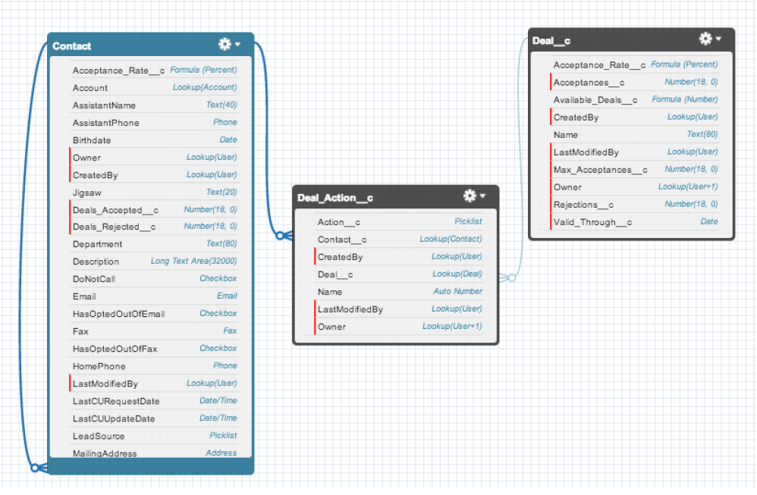

***Data Requirements***

**Contact**

Contact is a pet shop employee (customer) who calls in for the latest deals.

*Key Fields:*

▪ Acceptance_Rate__c – The percentage of deals a contact was offered and accepted (FORMULA)

▪ Deals_Accepted__c – The number of deals a contact was offered and accepted

▪ Deals_Rejected__c – The number of deals a contact was offered and rejected

**Deal__c**

Deal is a special offer for tropical fish that a contact can call in to accept or reject.

*Key Fields:*

▪ Acceptance_Rate__c – The percentage of times a deal was offered and accepted (FORMULA)

▪ Acceptances__c – The number of times a deal was offered and accepted

▪ Available_Deals__c – The remaining number of times a deal can be accepted (FORMULA)

▪ Max_Acceptances__c – The max number of times a deal can be accepted

▪ Rejections__c – The total number of times a deal was offered and rejected

▪ Valid_Through__c – The date a deal is available through

**Deal_Action__c**

Deal action represents the result of offering a deal to a contact.

*Key Fields:*

▪ Action__c – Indicates whether a deal was accepted or rejected by a contact (PICKLIST)

▪ Contact__c – A contact that was offered a deal (LOOKUP)

▪ Deal__c – The deal a contact was offered (LOOKUP)

***Access and Permissions Overview***

This section of the document details the access and permissions for the application, provided for the candidate’s reference. Configure OWD and Field Level Security using your discretion.

***Application Users***

There are two primary user groups for the application: **PP Warehouse Managers** and **PP Sales Reps**.

**PP Warehouse Managers** are Palmer Pets employees who manage the tropical fish warehouse and add new deals to Salesforce. They have the ability to create and edit all deals, but cannot see contact data or deal actions.

**PP Sales Reps** are Palmer Pets employees who work the phones for pet shop employees looking to hear about the latest deals and make new purchases. They are responsible for telling the pet shops about the latest deals and marking in Salesforce whether they rejected or accepted the deal. They can see all contacts related to accounts they own, and can see all deals and deal action.

***Profiles***

Create the following Profiles with Appropriate Visibility and CRUD

▪ **PP Warehouse Managers** can create, edit, and view all deals, but cannot see any contacts or deal actions.

▪ **PP Sales Reps** can view all contacts related to accounts they own, can view all deals, and can create (through the custom user interface) and view deal actions

***Logic Requirements***

This section of the document details the automation that the candidate is required to implement programmatically.

As contacts are offered deals, deal actions are created with two action statuses: “Accepted” and “Rejected.” When a deal action is created, four fields need to be updated on the related contact and deal. Please note that system administrators may update Deal Action records’ action statuses, or delete, or restore records previously deleted.

▪ **Contact.Deals_Accepted__c** – The total number of related deal action records with a status of “Accepted.” A deal action is related by Deal_Action__c.Contact__c and the deal action’s status is Deal_Action__c.Action__c.

▪ **Contact.Deals_Rejected__c** – The total number of related deal action records with a status of “Rejected.” A deal action is related by Deal_Action__c.Contact__c and the deal action’s status is Deal_Action__c.Action__c.

▪ **Deal__c.Acceptances__c** – The total number of related deal action records with a status of “Accepted.” A deal action is related by Deal_Action__c.Deal__c and the deal action’s status is Deal_Action__c.Action__c.

▪ **Deal__c.Rejections__c** – The total number of related deal action records with a status of “Rejected.” A deal action is related by Deal_Action__c.Deal__c and the deal action’s status is Deal_Action__c.Action__c.

***User Interface Requirements***

This section of the document details user interface-driven functionality that candidates must implement programmatically.

***Deal Viewer***

Palmer Pets would like to reduce the number of clicks it takes for sales reps to find the current available deals and log whether the contact is accepting or rejecting the deal.

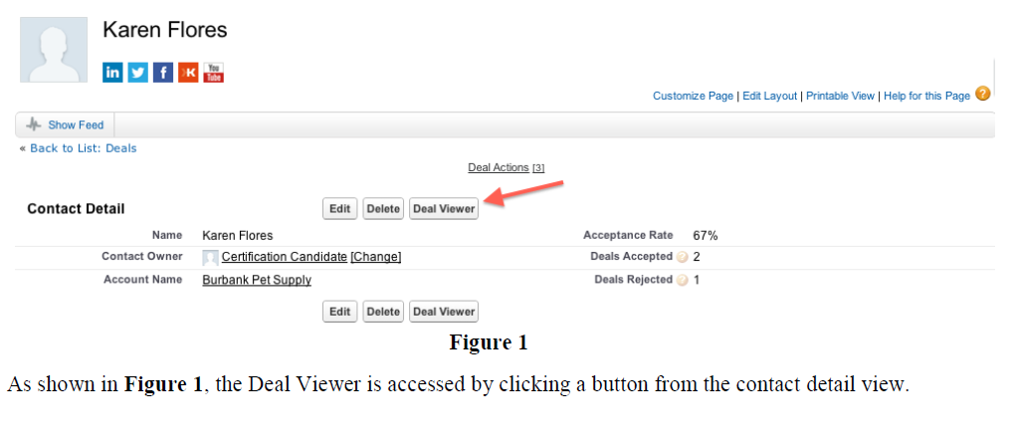

***Deal Viewer Screen***

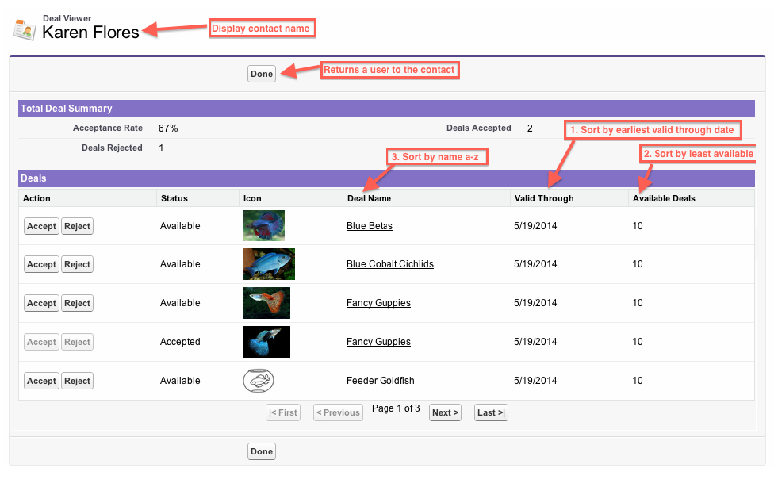**Figure 2**

As shown in **Figure 2:** Display the contact name at the top of the page. Add a Done button that when clicked returns the user to the contact page. Display a list of available deals sorted first by the earliest valid through date, then by the deal with the least available, and finally by the deal name from A–Z.

Deal results should exclude deals that are no longer valid (valid through date is in the past) or have no more available deals (available deals is less than or equal to 0).



**Figure 3**

As shown in **Figure 3**, deal results should include six columns:

• Actions column with accept and reject buttons

• Status column

• Icon

• Deal name

• Valid through date

• Available deals

For the icon column, the result should display an image driven by an attachment related to the deal. For the purpose of this assignment, you may assume only images will be attached—and at most one attachment per deal. If a deal does not have an attachment, a stock image, stored as a ***Static Resource*** “GenericFish” should be displayed as an icon.

For the status column, if a deal has not yet been accepted or rejected by the contact, a status of “Available” should be shown .If a deal has been accepted or rejected by the contact, the status should be “Accepted” or “Rejected” respectively and the Reject and Accept action buttons should be disabled.

When the Accept or Reject buttons are clicked for an available deal, a deal action record should be created and related to the deal and contact with a status of “Accepted” or “Rejected” respectively

If the deal is successfully accepted or rejected, the action buttons should be disabled and the status should change to “Accepted” or “Rejected” respectively .If an error is encountered while creating the deal action, the deal’s status should not change and the status button should not be disabled. Paging through results should not change these statuses or cause the Accept/Reject buttons to be re-enabled.

Total Deal Summary section should include the following data points:

• Acceptance Rate – Percent of all deals ever reviewed by contact that have been accepted

• Deals Accepted – Number of all deals ever that have been accepted by contact

• Deals Rejected – Number of all deals ever that have been rejected by contact

Total Deal Summary stats should start with current values and be updated immediately when a deal is accepted or rejected.

Deal results should be paginated with five deals shown per page. Pagination controls should be available for going to the first page, the previous page, the next page, and the last page of results. If on the first page, the First and Previous buttons should be disabled. If on the last page, the Next and Last buttons should be disabled. If there is only one page of results, the First, Previous, Next, and Last buttons should be disabled. The current page number should be displayed as well as the total number of pages of results.

***Validation Rules***

Create a validation rule to ensure the total available deals don’t fall below 0.